June 3, 1988

Smelter No:

by C. Viljoen

Distribution

H.A.R. Meiring

E.H.O. Meyer

H.P. Smit

A. Sousa-Poza

R. Haegele/ File

J. Rennie / R&D File

SLAG FUMING PROJECT

Plasmafume-100 and -200 Test Results

This report serves as a preliminary analysis from TCL' s side of the test data for both Plasmafume-100 and Plasmafume-200 test campaigns,. recently obtained from MINTEK. The final report by MINTEK on this test work will only become available by the next contact meeting on June 7. The test work has already been qualitatively described. This report· should thus be read in conjunction with Smelter Report No. 138/88.

Plasmafume-100 March 20-22, 1988

The objective was to demonstrate efficient operation with respect to accountability, recovery, and to produce partially oxidized fume in sufficient quantities for subsequent hydrometallurgical test work.

The planned 48-hour campaign was terminated after only 25 hours opera­ ting time, due to equipment failure as described in Report 138/88. Char (80% carbon content) made available by MINTEK was admixed as a reductant throughout the campaign to achieve 3%. carbon in feed, corresponding to 3.2 kg carbon per 100 kg slag. The mixed feed was fed by gravity through the furnace roof onto the molten slag bath. Quite often, however, the feed rate was erratic due to the furnace operating under overpressure.

After tap three fume was collected, after tap 12 and 17 the flue ducts were cleaned out, and after tap 22 the campaign was terminated and the furnace dug out. The following composites were analyzed:

Tap Nos.

1 - 3

4 - 12, including duct cleanouts

13 - 17, including duct cleanouts

18 - 22, including two dig out fractions

1 - 22, including dig outs, which reflects total campaign

Detailed and summarized data are reported in the appended tables.

The objective of producing only partially oxidized fume (i.e., con­ taining GeO as opposed to Ge02), could not be met. Rather, dead burnt (i.e., fully oxidized) fume had to be produced due to problems experienced with the afterburner. Also, the tenor of germanium in fume was exceptionally low, viz. 632 g/t on average.

Based on spent slag analysis, elimination of zinc, lead, and germanium was very satisfactory, being respectively 96, 99, and 98%. Elimination of iron, however, was found to be 46%, which is at variance with ther­ modynamic calculations that predict no iron reduction at the chosen carbon level. A possible explanation would be a reaction between slag and the graphite crucible; also, on three occasions the graphite elec­ trode broke and could not be recovered from the melt. On its turn, gallium elimination from slag improved with increasing iron reduction.

When one compares zinc extraction with specific energy consumption (viz. kWh/kg feed) and thermal efficiency (viz. 0.8/spec energy cons), the following correlation is obtained:

Tap No.

Zinc Extraction, %

Spec Energy Consumption, kWh/kg Thermal Efficiency,%

|  |  |  |  |  |
| --- | --- | --- | --- | --- |
| Tap No. | 1-3 | 4-12C | 18-22D2 | 13-17C |
| Zinc Extraction, % | 99 | 99 | 94 | 90 |
| Spec Energy Consumption, kWh/kg | 3.1 | 2.6 | 1.9 | 1.7 |
| Thermal Efficiency,% | 25 | 30 | 41 | 45 |

It should be noted that the thermal efficiency is based on the assum­ ption that the required specific energy consumption for slag fuming at 1500 C is 0.8 kWh/kg slag. Therefore, while the thermal efficiency appears to be in the order of 30% for this furnace (at reasonable zinc extractions), its overestimation could easily result in not being able to supply the minimum required energy of 0.8 kWh/kg slag. It is therefore suggested that an estimation of furnace efficiency be done by determining the slag temperature that is required to maximize metal elimination from slag. Whenever a new furnace is employed, the power levels should be adjusted such that this optimum slag temperature is achieved. This method is deemed more satisfactory than to wait for assay results before-the correct power levels for a new furnace can be decided upon.

Metal accountabilities were still rather unsatisfactory, as is reflected by the following results:

|  |  |
| --- | --- |
| Zinc | 81% |
| Lead | 58 |
| Iron | 86 |
| Silicon | 101 |
| Germanium | 58 |
| Gallium | 75 |

Even by assuming a calculated ('theoretical' in the tables) fume mass that allows 100% zinc recovery, accountabilities for the other metals remain poor (lead 72%, germanium 63%, gallium 78%). As will be noted, germanium behaved particularly disappointing: only 22% was recovered to fume, while 39% reported - unintentionally - to the metal phase; 2% remained in spent slag.

Although one of the objectives of this test seri s has been to demon­ strate better accountabilities due to extended campaigns (assuming that material may disappear in ducts or linings up to a saturation point), no improvement could be established as the campaign progressed. A tentative explanation could be found in the fact that baghouse temperatures at times exceeded 4oo·c.

A small amount of fume condensed on the inside of the furnace roof and was reclaimed after termination of metallic nature and assayed as follows:

|  |  |
| --- | --- |
| Zinc | approx 96 % |
| Lead | 0.5 |
| Silver | 0.2 g/t |
| Germanium | 8 |
| Cadmium | 0.02 |
| Iron | < 0.2 % |
| Silicon | < 0.2 |
| Copper | < 0.2 |
| Magnesium | < 0.05 |
| Aluminum | < 0.05 |
| Sulfur | < 0.01 |
| Molybdenum | < 0.001 |
| Arsenic | < 0.001 |
| Gallium | < 0.2 g/t |

Plasmafume-200 April 11-14, 1988

The objective was to obtain operating and performance criteria that would assist in designing of an industrial-scale plasma furnace. MINTEK was further requested to conduct some of the test runs under strongly reducing conditions. Again, the planned 48-hour campaign period was prematurely terminated after only 19 hours operating time, due to baghouse failure. Gas handling equipment unfortunately re­ stricted power levels to a mere 90 kW instead of the planned 120 kW.

This time, coal typical for that used at the Tsumeb Smelter (and also supplied by TCL) was used as a reductant at the following quantities:

|  |  |  |
| --- | --- | --- |
| Tap No. | Carbon in Feed, % | Carbon/Slag, kg/100 kg |
| 1 - 8 | 2.05 | 2.08 |
| 9 - 11 | 4.02 | 4.28 |
| 12 - 14 | 7.33 | 8.37 |

Composite mass. balances were calculated, and are presented in the attached tables, according to the above categories.

A total of 112.5 kg scrap iron was charged into the furnace during heat-up, of which only 76.7 kg could be tapped before the campaign proper was started; therefore, these figures had to be included in the mass balance {under tap no. 0 in the tables).

Thermodynamic calculations predict a direct relationship between con­ centration of carbon in feed (i.e., the 'reducing power') and metal elimination from slag. The following table compares calculated with experimentally obtained data:

|  |  |  |  |  |  |  |
| --- | --- | --- | --- | --- | --- | --- |
|  | Carbon in Feed, % | Zn | Pb | Ge | Ga | Fe |
| Predicted | 2.5 | 91 | 100 | 99 | 0 | 0 |
| Experiment | 2.1 | 85 | 86 | 95 | 32 | 19 |
|  |  |  |  |  |  |  |
| Predicted | 4.4 | 99 | 100 | 100 | 100 | 40 |
| Experiment | 4.0 | 95 | 90 | 96 | 66 | 32 |
|  |  |  |  |  |  |  |
| Predicted | 7.2 | 100 | 100 | 100 | 100 | 99 |
| Experiment | 7.3 | 94 | 91 | 98 | 72 | 55 |

Zinc seems to follow the trend, although in all cases it was found to be lower by 5% when compared to predicted values, while the extraction of lead was in all cases much lower than predicted. It is suggested that this may be due to underestimating the furnace losses (to my mind arbitrarily fixed at 30 kW), which could have resulted in a lower than theoretically required specific energy consumption. Therefore it is debatable whether the objective of obtaining performance criteria for upscaling was in fact met.

Although, at 2% carbon in feed already 19% of the iron in slag was reduced, and at 4% even 32%, no metal phase could be tapped, was how­ ever eventually recovered in the dig-out at the end of the campaign. With this the iron accountability, which was initially poor, improved to 97%. Still, it is difficult to explain the poor correlation between predicted and actually obtained reduced iron for the various levels of carbon in• feed.

In this campaign metal accountability was slightly better (germanium 97%) than established for the Plasmafume-100 test series, although still rather unsatisfactory: Even with the calculated fume mass one cannot account for 13% of the lead and 24% of the gallium. Here, losses due to excessive baghouse temperatures cannot have been the cause since they were carefully controlled at 80 C. It would be interesting to assay the reclaimed furnace refractory lining for the missing elements.

Summary

1. Both campaigns had to be terminated failures: cathode failure leading case of the Plasmafume-100 series, case of the plasmafume-200 series. prematurely due to equipment to severe stray arcing in the and burnt-out baghouse in the

2. In particular the off-gas handling equipment appeared ill designed for the purpose and operated unsatisfactorily, thereby interfering with smooth operation.

3. Control of the intended reduction level during the Plasmafume-100 campaign was impaired by the reaction of the graphite crucible with the slag charge, resulting in overreduction and formation of a iron metal phase. The magnesia lining in the 200 kVA furnace prevented this phenomenon in the Plasmafume-200 campaign.

4. The way in which the power requirement was estimated, and the extent to which the chosen power could be maintained, appeared not quite satisfactory. Reference is made to the degree of power fluctuations clearly shown in the attached tables.

5. While most of the Plasmafume-100 results showed satisfactory metal eliminations from slag, this was not so in the case of the Plasma­ fume-200 campaign, which can perhaps be attributed to an over­ estimated thermal efficiency of the 200 kVA furnace.

6. The aspect of sufficient retention time for complete elimination was not yet considered, being perhaps overshadowed by the effects of insufficient power levels in cases where poor eliminations were found.

7. Metal accountability still remains very much of a mystery, in spite of campaign lengths that substantially exceeded those carried out with the 50 kVA furnace.

8. The zinc/lead alloy detected after the Plasmafume-100 campaign is believed to simulate to an extent the product that one could duly expect from the Magnatherm metal condenser. This condenser was developed by the University of Pretoria and is based on the principle of heterogeneous nucleation; it will form part of Samancor's 10 MW demonstration plant for the production of magnesium metal.

PLASMA 100 TEST RESULTS

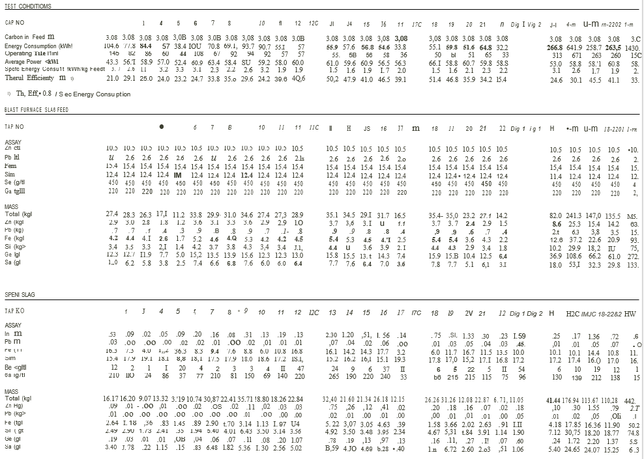

PLASMA 100 TEST RESULTS

PLASMA 100 TEST RESULTS – SUMMARY

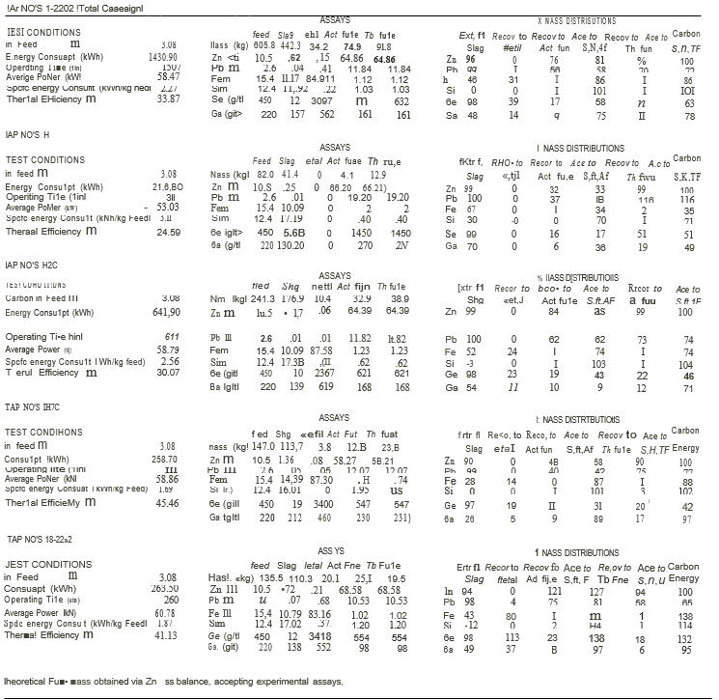

PLASMA 200 TEST RESULTS

PLASMA 200 TEST RESULTS

PLASMA 200 TEST RESULTS

PLASMA 200 TEST RESULTS – SUMMARY

